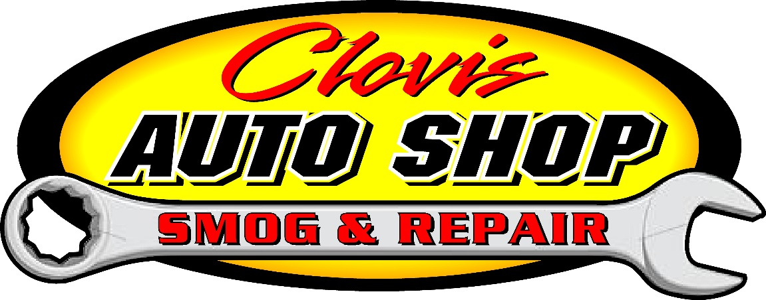
DROP-OFF FORM
Today’s Date: ___________________ Time of drop-off: ___________A.M. / P.M.
Please try to have vehicle done by date: _____________ Time: _______________A.M / P.M.
Customer Name: ______________________________________________________________________
ADDRESS: ____________________________________________________________________________
CITY: ______________________________________ ZIP: ______________________________________
CELL NUMBER: ___________________________ ALT PHONE: __________________________________
EMAIL ADDRESS: ______________________________________________________________________

YEAR: ___________________________________________
MAKE: __________________________________________
MODEL: _________________________________________
COLOR: __________________________________________
LICENSE PLATE: ____________________________________
□ Oil & Filter Change
□ Oil Leaks
□ Flush Cooling System
□ Vibration or Noise
□ Smog Inspection
□ Service Air Conditioner

□ Check & Rotate Tires
□ Transmission Service
□ Brake Inspection
□ Pre-Trip Inspection
□ Check Engine Light On
□ Align Front End

□ Engine Running Poorly
□ Low Fuel Mileage
□ Replace Wipers
□ __________Mile Service

Other Services Needed/Description of Problem: __________________________________________________________________________________________________________________________________________________________________________________________________________________________________________
WE ACCEPT: PERSONAL CHECKS, CASH, CarCareONE, AND 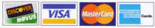
I hereby authorize the repair work herein set forth to be done along with the necessary material and agree that you are not responsible for loss or damage to vehicle or articles left in vehicle in case of fire, theft, or any other cause beyond your control or for any delays caused by unavailability of parts or delays in parts shipments by the supplier or transporter. I hereby grant you and/or your employees permission to operate the vehicle herein described on streets, highways or elsewhere for the purpose of testing and/or inspection. An express mechanic’s lien is hereby acknowledged on above vehicle to secure the amount of repairs thereto.
Customer Signature x ________________________________________Date: ______________
(This repair shop is not responsible for personal property left in cars such as guns, cameras, clothing, money, cell phones, radar detectors, etc.)

NOTICE: THIS FORM MUST BE SIGNED BEFORE WE CAN BEGIN WORK ON YOUR VEHICLE.

